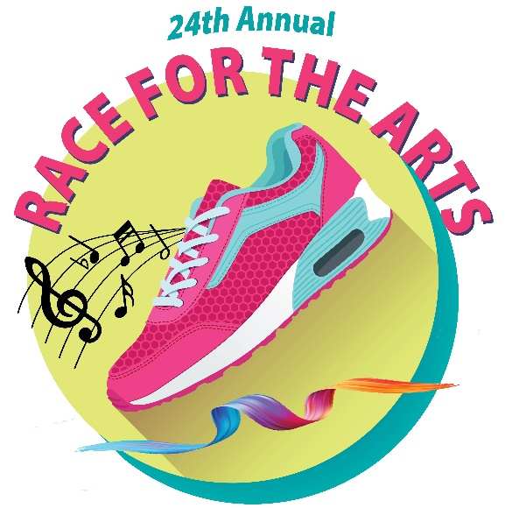
Race for the Arts 2023
Contact:
Sally Rice
Event Coordinator
Office: 916.966-8893
Fax: 916.966-8907
Cell: 916.715.9711
E-mail: sallyrice@raceforthearts.com or sriceecp@aol.com

Performance Participation

Race for the Arts
5 km Run/Walk & Kids Fun Runs /Arts Festival
Saturday Morning
August 26
8:00 am – 1:00 pm
William Land Park
Next to Fairytale Town
Sacramento (by Amphitheatre)
We prefer to perform: Amphitheatre □ Racecourse □ or Both □

A brief description of performance (information required):
__________________________________________________________________________________________
__________________________________________________________________________________________
Number of performers (information required): _____________________________________________
Length of performance (information required): ____________________________________________
Sound source (iPod, CD, etc) (information required): ______________________________________
Audio or equipment needs (information required): ________________________________________
Requested time of performance (not guaranteed): _______________________________________
Please complete form and fax it to 916.966-8907 or mail it to P.O. Box 799, Folsom, CA 95763, or email to sallyrice@raceforthearts.com no later than Friday, August 4. Any questions, please contact Sally Rice. You will be contacted with performance time confirmation no later than August 11.

Organization ____________________________________________________________________

Contact Name ___________________________________________________________________

Phone ____________________________________ Fax _______________________________

Email __________________________________________________________________________

Signature _________________________________________ Date ______________________

