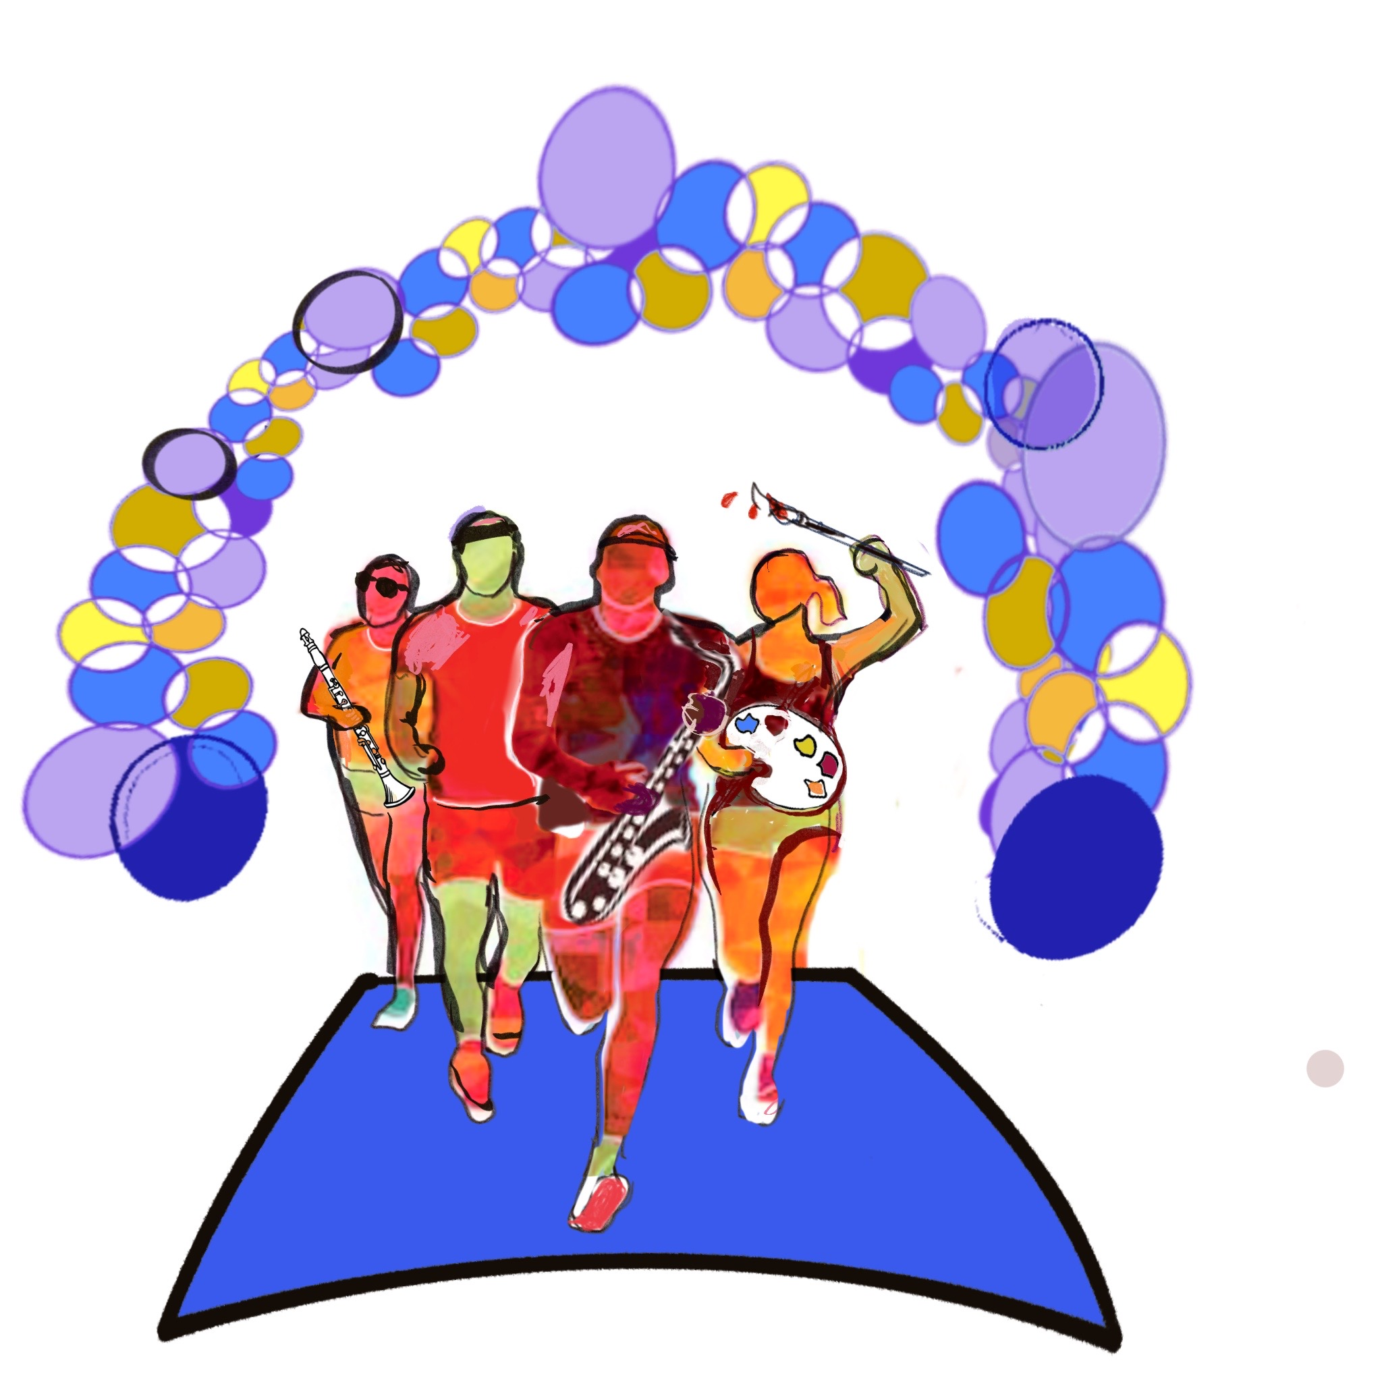
Race for the Arts Celebrates 22 Years!
Contact:
Sally Rice
Event Coordinator
Office: 916.966-8893
Fax: 916.966-8907
Cell: 916.715.9711
E-mail: sriceecp@aol.com
22nd Annual
RACE FOR THE ARTS
5K & Kids Fun Runs – FREE Arts Festival

Performance Participation Form

Saturday Morning
August 22
8:00 am – 1:00 pm
You will be contacted with your performance time
We are continuing to retain this date at this time; however, because of COVID-19, please check back often for any date changes or Race updates.
William Land Park, Sacramento
Across from Sacramento Zoo, next to Fairytale Town (by Amphitheatre)
We prefer to perform: Amphitheatre □, Racecourse □, or both □

A brief description of performance (information required):
__________________________________________________________________________________________
__________________________________________________________________________________________
Number of performers (information required): _____________________________________________
Length of performance (information required): ____________________________________________
Sound source (iPod, CD, etc) (information required): ______________________________________
Audio or equipment needs (information required): ________________________________________
Requested time of performance (not guaranteed): _______________________________________

Please complete form and fax it to 916.966-8907 or mail it to P.O. Box 799, Folsom, CA 95763, or email to sriceecp@aol.com no later than Friday, August 9. Any questions, please contact Sally Rice (916-966-8893) or sriceecp@aol.com. You will be contacted with performance time confirmation no later than August 14.

Organization ____________________________________________________________________

Contact Name ___________________________________________________________________

Phone ____________________________________ Fax _______________________________

Email __________________________________________________________________________

Signature _________________________________________ Date ______________________

