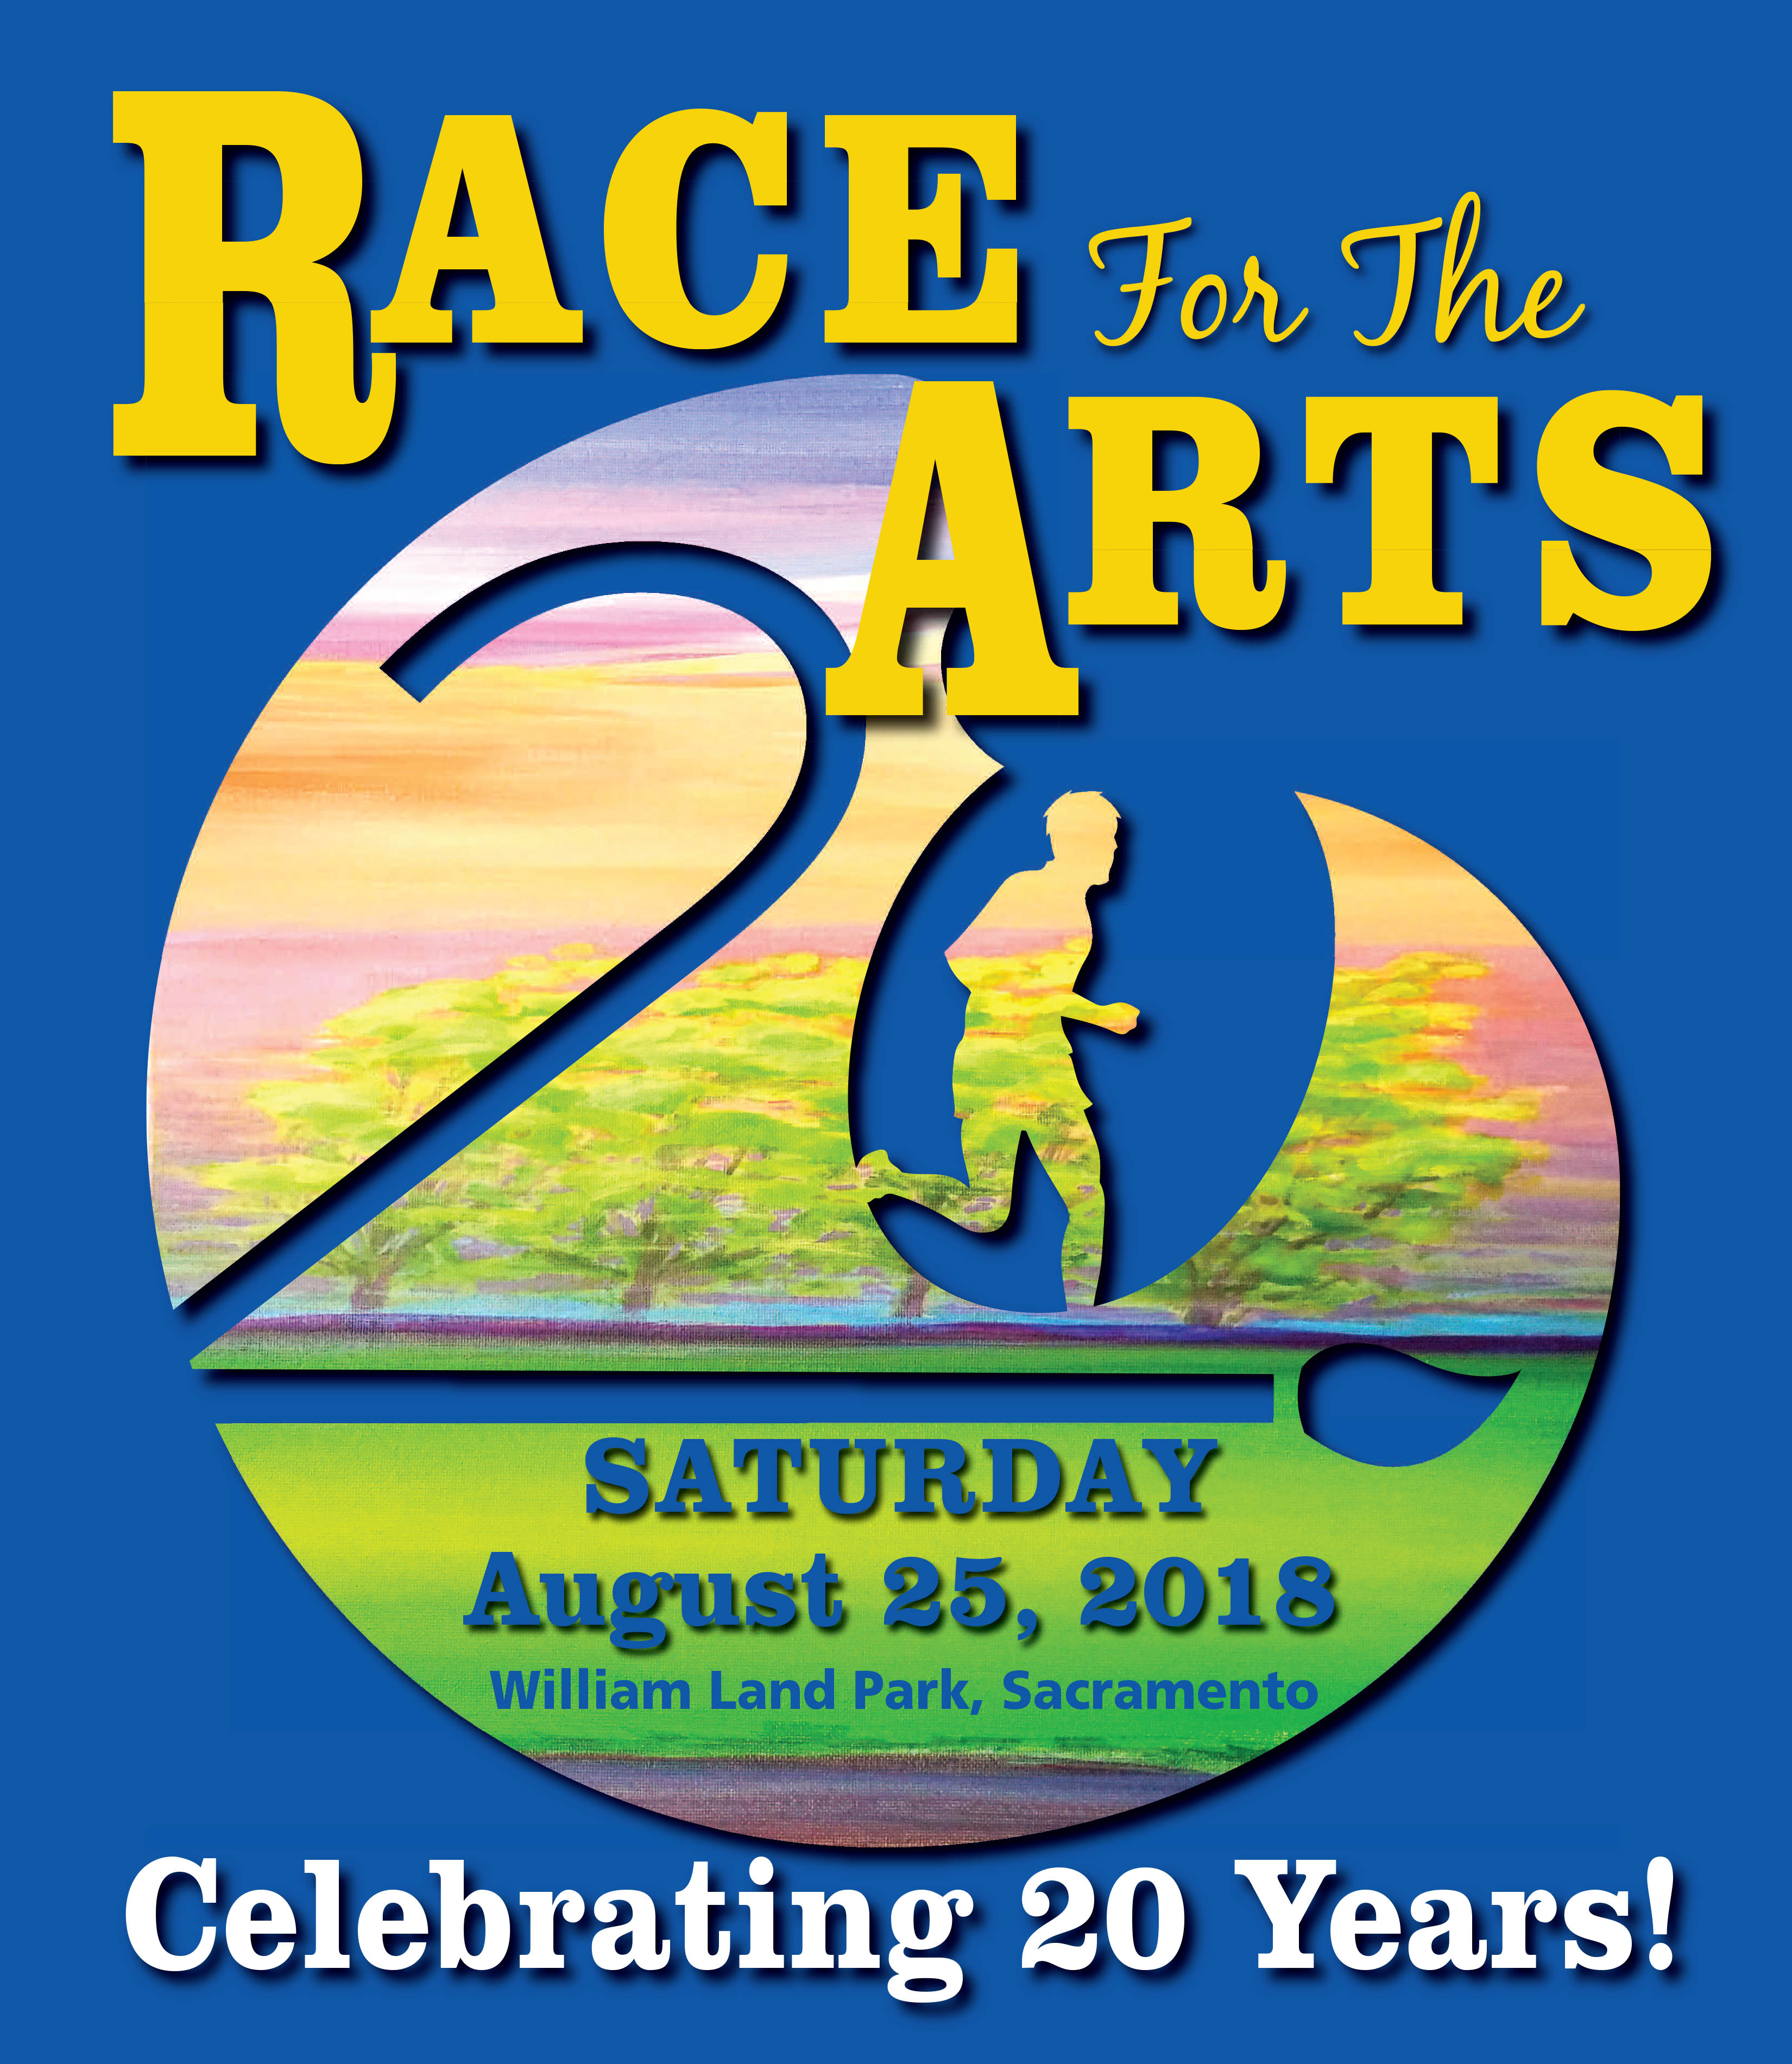
5K WALK/RUN and Kids Fun Runs
& Arts Festival

______________________________________________________________________________________________
(Personalize and enter the name of your California nonprofit visual, literary, performing,
or cultural arts organization or your school music, literary, drama or art program)

We receive 100% of pledges designated to us on Race for the Arts Pledge Form -
If we are not listed, be sure to write us in

EVENT: RACE FOR THE ARTS – 5 km Run/Walk and Fun Runs
DATE: SATURDAY, August 25, 2018
TIME: 7:00 a.m. - Registration
8:10 a.m. – Kids Fun Runs (1/4 mile 6 & under, 1/2 mile 7-12)
8:35 a.m. – 5 km Run/Walk Start (3.1 miles)
PLACE: WILLIAM LAND PARK, Sacramento
COST: Adults - $30 (register after August 18 - $35)
Kids 15 and under - $15 (register after August 19 - $15, no change)
20% discount for groups of 10 or more (must register together)

Entry Fee Includes Race T-shirt & Socks Exclusively Designed by Trumpette

916.966.8893

www.raceforthearts.com

Arts Festival, Interactive Booths, Entertainment, Post-Race Party
MORE THAN A RUN — IT’S AN EXPERIENCE

Obtain pledges through social media, websites, newsletters, board meetings, incentives,
teams, families, friends, co-workers, and challenges

Proudly sponsored by
The SACRAMENTO BEE, KCRA 3, KQCA MY58, KFBK, SACTOWN MAGAZINE, CAPITAL PUBIC RADIO, INSIDE PUBLICATIONS, SACRAMENTO PARENT, INSIDE PUBLICATIONS, SACRAMENTO PARENT, Starbucks, Milgard Windows & Doors, Hobrecht Lighting, Yelp, Sacramento Visitors & Convention Bureau, Sacramento Metropolitan Arts Commission, California Family Fitness, Associated Sound, Trumpette, Pizza Rock, Riverview Media Photography, Sacramento New Technology High School, Sacramento 365, Bouchard Communications, California Family Fitness

